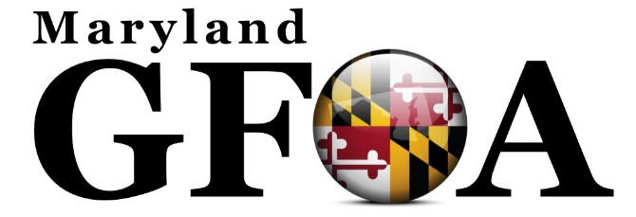
Disclaimers now viewable on the website under ABOUT

Content Disclaimer
All information provided on official Maryland Government Finance Officer Association (MDGFOA) sites is provided for information purposes only and does not constitute a legal contract between MDGFOA and any person or entity unless otherwise specified. Information on the MDGFOA website is subject to change without prior notice. Although every reasonable effort is made to present current and accurate information, MDGFOA makes no guarantees of any kind.
MDGFOA website may contain information that is created and maintained by a variety of sources both internal and external to MDGFOA. MDGFOA does not control, monitor or guarantee the information contained in these sites or information contained in links to other external websites, and does not endorse any views expressed or products or services offered therein. In no event shall MDGFOA be responsible or liable, directly or indirectly, for any damage or loss caused or alleged to be caused by or in connection with the use of or reliance on any such content, goods, or services available on or through any such site or resource.
MDGFOA reserves the right to refuse the provision of links to any external content, for whatever reason deemed fit.
Link Disclaimer:
Any links to external websites and/or non-MDGFOA information provided on association pages or returned from association web search engines are provided as a courtesy. They should not be construed as an endorsement by MDGFOA of the content or views of the linked materials.

